PurityLoop AI: Automated Waste Contamination Detection and ESG Analytics System

Group Research Proposal — Sections Assigned to Talvin Lee Gen Wei
Student: Talvin Lee Gen Wei Student ID: [Student ID] Programme: Bachelor of Business Analytics (Honours) Course: BAA3284 — Capstone Project Supervisor: Dr. Narishah Mohamed Salleh Institution: Sunway University, Petaling Jaya, Selangor, Malaysia Submission Date: May 2026
*This document contains §1.2, §2.1, §2.2, and §3.4.1/§3.4.2/§3.4.4 as assigned to Talvin Lee Gen Wei in the group delegation matrix. All remaining chapter sections are authored by other team members.*

Chapter 1: Introduction

1.2 Problem Statement
The manual waste sorting process deployed in Malaysian Material Recovery Facilities (MRFs) exhibits three interrelated failure modes that are structurally irreducible without computational intervention. Each failure independently degrades MRF operational outcomes; together they form a compounding system failure that no current point solution resolves.
Failure Mode 1 — Perceptual Ambiguity at the Material Boundary. Human RGB colour vision cannot discriminate material composition where spectral signatures diverge only in wavelength bands outside the visible range. Transparent polyethylene terephthalate (PET) bottles and soda-lime glass containers share near-identical reflectance profiles in the 380–700 nm visible spectrum; distinguishing spectral signatures lie in the near-infrared (NIR) and short-wave infrared (SWIR) bands inaccessible to both human perception and standard industrial RGB cameras (Terven et al., 2023). Under industrial conveyor throughput conditions, human sorters operate under severe time constraints — insufficient temporal resolution for deliberate material identification when visual properties are ambiguous between material classes. The process reduces to pattern-matching heuristics that systematically fail at class boundaries where colour, texture, and shape features are shared across material categories. Faizul Rakib Sayem et al. (2024) quantify this failure mode at 30–40% sorting error rates across heterogeneous waste streams under operational conditions, establishing the performance floor that motivates automated sorting system design. A sorting error rate of this magnitude is structurally analogous to a 30–40% defect rate in a manufacturing quality control process — a threshold that would halt production in any comparable industrial context.
Failure Mode 2 — Structural Incapacity for Machine-Readable ESG Data Generation. Manual sorting produces no computable output. Each classification decision is a physical diversion of an item into a material stream: an irreversible physical action that generates no timestamp, no confidence measure, no class label, and no digital audit trail. Corporate sustainability commitments under GRI Standards (GRI 306: Waste), TCFD climate-related financial disclosures, and ISSB sustainability reporting frameworks require per-item, timestamped, classification-confident waste composition data to underpin carbon offset claims, waste diversion rates, and material recovery reporting. Manual MRF operations cannot generate such data without parallel human data entry — a process that introduces transcription error, sampling bias, and retrospective estimation error incompatible with the granularity demanded by regulatory-grade disclosures. Mustafa et al. (2025) systematically reviewed 135 peer-reviewed articles on AI and sustainability reporting, identifying research fragmentation and the absence of robust empirical implementation frameworks as barriers to AI adoption in ESG contexts, and concluding that AI integration in sustainability reporting remains substantially underexplored. The accountability gap PurityLoop AI addresses — the absence of digital, per-item waste classification records — is structurally an operational architecture problem: the data cannot exist until the sorting process that generates it is automated.
Failure Mode 3 — Undetected Lithium-Ion Battery Hazard. The proliferation of lithium-ion battery (LIB)-containing consumer electronics in the general waste stream has introduced a fire ignition hazard that manual visual inspection cannot systematically detect. LIB cells concealed within discarded electronic equipment or commingled with non-combustible waste are indistinguishable from similarly sized non-hazardous items at conveyor speed — a cylindrical 18650 format LIB cell projects to approximately 35×10 pixels at standard camera-to-conveyor distances of 0.5 m, a spatial scale at which visual discrimination from AA batteries, glass fragments, or similar cylindrical items is unreliable. When LIB-containing items reach the MRF crushing or shredding stage, mechanical impact on the cell casing can initiate thermal runaway — a self-sustaining exothermic decomposition reaction that ignites surrounding conveyor materials and recovered bales. Atsushi Terazono et al. (2024) analysed ignition and fire-related incidents across municipal waste treatment facilities in Japan, documenting that 80–90% of facility fire incidents were attributable to LIB-caused ignition during the crushing stage, despite LIB-containing items comprising only approximately 0.3% of total non-combustible waste by weight. This asymmetry — 0.3% prevalence generating 80–90% of fire incidents — defines battery detection as a recall-constrained safety engineering problem: even a 5% false-negative rate on a 0.3% prevalence class produces a non-trivial fire exposure rate at facilities processing hundreds of tonnes per day. No standardised automated detection mechanism for LIBs exists within Malaysian MRF infrastructure (Arishi, 2025; Ren et al., 2024).

These three failures are causally coupled: sorting inaccuracy inflates bale contamination, contamination forecloses downstream ESG accountability, and undetected batteries create fire exposure that compounds the operational loss from both contamination and data absence. PurityLoop AI addresses this compound failure through three integrated technical subsystems:
(1) a YOLOv8m-seg nine-class detection and instance segmentation pipeline providing real-time automated waste classification;
(2) a Python RPA watchdog ingestion pipeline converting per-detection inference records into audit-ready ESG database entries with per-item CO₂e carbon offset calculation;
(3) a gamified Eco-Credit web application targeting contamination at source before MRF intake, converting the upstream recycling behaviour problem from an uncontrolled variable into a measurable intervention.

Chapter 2: Literature Review

2.1 Literature Search Protocol
Literature was retrieved from Scopus and Google Scholar, restricted to peer-reviewed journal publications between 2021 and 2026, with priority assigned to journals ranked Q1 and Q2 under the Scimago Journal Rankings (SJR). Boolean search operators were applied across five thematic clusters: (1) ("waste classification" OR "waste detection") AND ("YOLO" OR "instance segmentation") AND ("mAP" OR "conveyor belt"); (2) ("waste dataset" OR "benchmark") AND ("class imbalance" OR "hazardous" OR "battery"); (3) ("ESG reporting" OR "sustainability disclosure") AND ("artificial intelligence" OR "machine learning"); (4) ("gamification" OR "token economy") AND ("recycling behaviour" OR "waste sorting"); (5) ("DMAIC" OR "Lean Six Sigma") AND ("machine learning" OR "Industry 4.0"). Inclusion criteria: peer-reviewed, DOI-registered, 2021–2026, empirical study or systematic review. Exclusion criteria: conference abstracts without full peer-reviewed publication, preprints, and grey literature.

2.2 Theme 1: Deep Learning for Automated Waste Classification and Contamination Detection

2.2.1 Evolution of Object Detection Architectures in Waste Management
The application of computer vision to waste classification has progressed through three architectural generations, each addressing a fundamental limitation of its predecessor while introducing new constraints that motivate the next transition.
First generation — image-level classifiers. The inaugural application of deep convolutional networks to waste classification employed ResNet, VGG, and Inception architectures as image-level classifiers: a single category label per image crop as output. On controlled single-item datasets under clean-background studio conditions, these architectures achieved classification accuracy exceeding 90% (Md. Nahiduzzaman et al., 2025). However, image-level classifiers are architecturally incapable of serving MRF operational requirements. A MRF conveyor frame contains 8–15 simultaneously visible, partially occluded items of mixed material classes; an image-level classifier produces one output vector per image, not per item. Without spatial localisation and per-instance separation, the classifier cannot identify which pixels belong to which item — the fundamental prerequisite for any downstream sorting action or per-item mass estimation. The performance on clean single-item images is therefore structurally unrepresentative of MRF deployment: a 90% accuracy on TrashNet images translates to near-zero utility on a live conveyor frame where the input distribution shares nothing with the training distribution except item categories.
Second generation — two-stage region-proposal detectors. The adoption of Faster R-CNN and Mask R-CNN resolved the multi-instance localisation problem by introducing a region proposal network (RPN) that generates candidate object bounding boxes followed by per-region feature extraction and classification. For waste detection, this architectural advance was necessary but insufficient. The two-stage architecture imposes a hard throughput ceiling: at 5–15 FPS on GPU hardware, these detectors cannot serve the real-time inference requirement of a continuously operating conveyor belt, where missing a detection window means a waste item passes the camera without classification (Md. Nahiduzzaman et al., 2025). The RPN's selective search mechanism and the per-region ROI pooling introduce latency at each stage that compound to place the system below the operational frame rate threshold (Terven et al., 2023).
Third generation — single-stage YOLO-family detectors. YOLO architectures eliminated the two-stage bottleneck by performing detection and classification in a single forward pass through a shared backbone, producing bounding box coordinates and class probabilities simultaneously from a dense grid prediction over the full image. This design achieves real-time inference rates compatible with conveyor belt throughput requirements. The critical remaining limitation of early YOLO bounding-box outputs for waste applications is the inability to estimate item mass or volume for CO₂e carbon accounting: axis-aligned rectangular bounding boxes provide poor area approximations for the irregular, non-convex contours of real waste items (crumpled paper, multi-fragment glass, textile folds). Instance segmentation architectures extend YOLO detection with per-instance pixel-level masks, enabling accurate contour capture that resolves the mass estimation limitation. Ren et al. (2024) demonstrated that architectural augmentation of YOLOv8 (multi-resolution strategy, RepViT attention modules) yields a 3.6% mAP@0.5 improvement with 15.09% reduced model volume on a 10-class waste dataset — confirming that YOLOv8-seg represents the current performance frontier for multi-class waste detection, while also confirming that Ren et al.'s 10-class taxonomy, like all existing benchmarks, excludes hazardous item classes.
The critical and unresolved failure across all three architectural generations is the systematic exclusion of lithium-ion battery classes from both training datasets and model evaluation benchmarks. Standard waste detection datasets — TrashNet, Garbage Classification v2 (GCv2), RealWaste, Waste25k — contain zero battery-annotated images. This exclusion is not incidental: it reflects the absence of MRF operational safety engineering as a design criterion in academic waste detection research. The consequence is a generation of models validated on non-hazardous recyclable categories with no demonstrated or intended capability on the class that poses the highest operational consequence per detection failure.
Figure 1: Three-Generation Computer Vision Architecture Evolution for Waste Classification
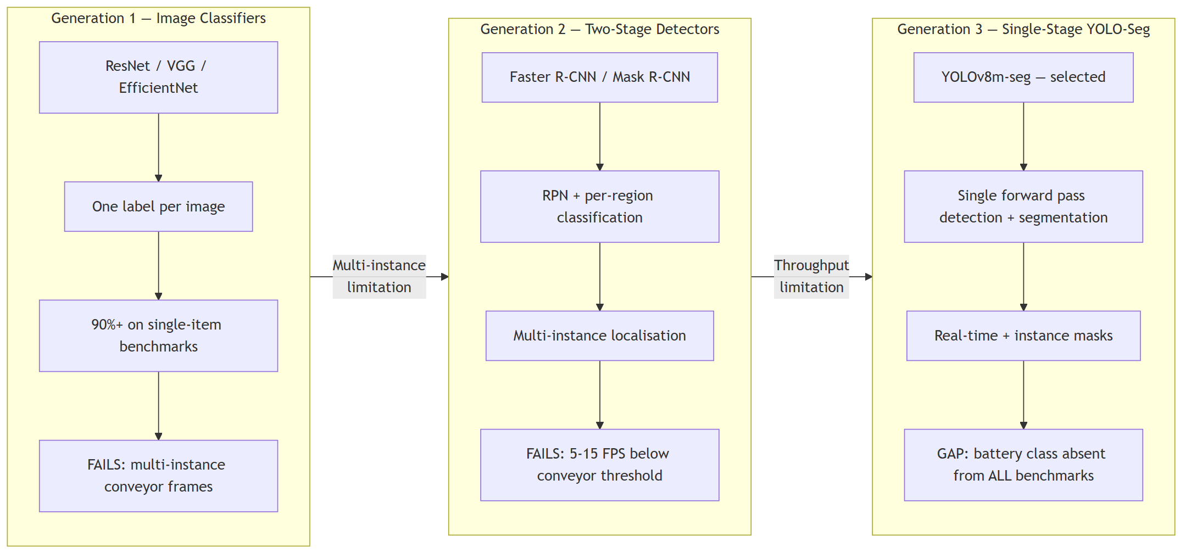
Figure 1: Three-Generation Computer Vision Architecture Evolution for Waste Classification

2.2.2 YOLOv8 Performance in Waste Detection Tasks
YOLOv8 (Terven et al., 2023) establishes the current state-of-practice for single-stage detection and instance segmentation, consolidating advances from prior YOLO iterations into a unified architecture: a CSPDarknet backbone with C2f (Cross Stage Partial with two bottleneck convolutions) modules replacing C3 blocks, an anchor-free decoupled detection head separating classification and regression branches, and a PANet feature pyramid neck providing bidirectional multi-scale feature fusion. Within waste classification tasks, YOLOv8's performance has been validated at operational thresholds by two independent empirical evaluations. Arishi (2025) reported mAP@0.5 of 93%, precision 89%, and recall 88% on a real-time household waste detection evaluation — the highest single-study mAP@0.5 reported for a YOLOv8 waste classification evaluation. Md. Nahiduzzaman et al. (2025) achieved 91% nine-class classification accuracy on a 35,264-image waste dataset using a parallel lightweight depth-wise separable CNN ensemble, establishing the performance ceiling for nine-class waste taxonomies that YOLOv8-seg must approach or exceed.
However, a critical limitation applies to both evaluations: Arishi (2025) evaluates a six-class taxonomy on household waste imagery under residential collection conditions; Md. Nahiduzzaman et al. (2025) evaluate a nine-class taxonomy on a dataset without a hazardous item class. Neither evaluation addresses MRF conveyor imaging conditions characterised by item overlap, motion blur, variable illumination, and industrial-scale throughput. The transferability of reported mAP figures to operational MRF deployment — as opposed to controlled dataset evaluation — remains unvalidated in the published literature.
More critically: no existing peer-reviewed study evaluates any YOLOv8 variant — including YOLOv8-seg — on a dataset incorporating a dedicated lithium-ion battery class alongside standard recyclable categories. Arishi (2025) and Ren et al. (2024) explicitly exclude hazardous items. Md. Nahiduzzaman et al. (2025) define nine waste classes without a hazardous item class. This systematic gap means the battery detection recall achieved by any current model on an MRF-relevant dataset is unknown — there is no published benchmark against which to anchor safety-critical recall requirements. PurityLoop AI addresses this gap by constructing the first training dataset with explicit battery class coverage at scale (12,814 images, 421% increase over the baseline 2,458-image coverage across fused source datasets) and evaluating battery class recall explicitly against a safety-critical threshold gate.

2.2.3 Model Selection Justification: YOLOv8m-seg
YOLOv8m-seg is selected as PurityLoop AI's detection backbone through systematic evaluation across five criteria against the performance requirements defined in the project specification. The selection rationale is documented here in terms of necessary and sufficient conditions, not relative preference.
Criterion 1 — Accuracy at the nine-class scale. The 'm' (medium) variant achieves mAP@0.5:0.95 of 50.2 on COCO val2017 — the optimal efficiency-accuracy operating point within the YOLOv8 family for a 27.3M parameter budget (Terven et al., 2023). The 's' (small) variant is excluded: its reduced feature extraction capacity underperforms on small object classes, and lithium-ion cells at conveyor imaging distance (projected size ≈ 35×10 pixels at 640×640 input) are small objects by COCO benchmarking conventions. The 'l' and 'x' variants provide 1–3% additional mAP@0.5:0.95 at 2×–4× the parameter count, exceeding single-node GPU VRAM constraints without proportionate safety-relevant performance gain.
Criterion 2 — Instance segmentation output (necessary condition). YOLOv8m-seg generates per-instance pixel-level masks via a 32-prototype segmentation head at 160×160 resolution. This is a necessary condition for the CO₂e carbon offset calculation: mask pixel area provides the item volume proxy required for per-item mass estimation in the LCA substitution formula (Wang et al., 2022). No classification-only architecture (ResNet, EfficientNet) or bounding-box detector (Faster R-CNN, EfficientDet, YOLOv8-detect) satisfies this requirement. Segmentation output is a hard architectural prerequisite, not a performance optimisation.
Criterion 3 — Real-time throughput on CUDA hardware. YOLOv8m-seg achieves real-time inference rates on mid-tier CUDA GPU hardware, satisfying the ≤ 500 ms end-to-end latency constraint for conveyor belt deployment (Terven et al., 2023). Faster R-CNN's two-stage architecture (5–15 FPS) and EfficientDet's memory-intensive compound scaling are incompatible with the latency target under single-node deployment. YOLOv8s-seg meets the latency target but fails Criterion 1 for small-object (battery) detection.
Criterion 4 — Battery class detection capability (safety-critical condition). The three-scale feature pyramid (P3/stride-8 at 80×80, P4/stride-16 at 40×40, P5/stride-32 at 20×20) provides the spatial resolution required for small-object detection. The P3 feature map at stride-8 granularity provides 8-pixel receptive fields at input scale — within the detection sensitivity range for 18650-format LIB cells at the target projection size of approximately 35×10 pixels. The anchor-free regression head with Distribution Focal Loss (DFL) provides sub-pixel localisation accuracy that further supports small elongated object detection. No competing architecture provides documented equivalent capability on hazardous waste classes (Arishi, 2025; Md. Nahiduzzaman et al., 2025 — both confirm absence of hazardous class evaluation).
Criterion 5 — Ecosystem maturity and deployment readiness. The Ultralytics Python API provides a production-stable implementation with native ONNX, TensorRT, and CoreML export for deployment-time inference optimisation; per-epoch training telemetry (mAP@0.5, mAP@0.5:0.95, per-class precision/recall, confusion matrix); and an ImageNet-pretrained initialisation checkpoint (yolov8m-seg.pt) enabling transfer learning from a large-scale visual representation. No competing architecture at this scale provides equivalent tooling maturity and deployment pathway documentation (Terven et al., 2023).
Table 2.2 — Model Architecture Selection Summary
Architecture | mAP@0.5 (waste-domain) | Segmentation output | Real-time on CUDA | Battery class tested | Ecosystem maturity
ResNet-50 / EfficientNet (classifier) | ~90% (single-item datasets) | No | High throughput | No | High
Faster R-CNN | ~88–92% | No (without Mask R-CNN) | 5–15 FPS — below threshold | No | High
EfficientDet | ~88–93% | No | 15–25 FPS — marginal | No | Medium
YOLOv8s-seg | ~85% (small datasets) | Yes — 32-prototype | High — meets target | Not evaluated | High
YOLOv8m-seg (selected) | ≥ 85% (9-class target) | Yes — 32-prototype, 160×160 | Real-time; hardware-dependent (Terven et al., 2023) | Yes — class 7 safety gate designed | High (Ultralytics API)
YOLOv11 / RT-DETR | Comparable to YOLOv8m | Yes | Comparable | Not evaluated | Low — insufficient waste-domain validation

Chapter 3: Methodology

3.4 Model Architecture and Training

3.4.1 YOLOv8m-seg Architecture
YOLOv8m-seg is a single-stage instance segmentation network whose architecture decomposes into four functionally distinct subsystems (Terven et al., 2023):
(1) a CSPDarknet backbone with C2f cross-stage partial bottleneck modules;
(2) a PANet bidirectional feature pyramid neck;
(3) an anchor-free decoupled detection head;
(4) a 32-prototype instance mask segmentation head
CSPDarknet Backbone — C2f Module Design. The C2f module (Cross Stage Partial with two convolutional bottlenecks) replaces the C3 blocks used in YOLOv5. Each C2f block splits its input feature map along the channel dimension into two partitions. One partition traverses a sequential stack of n Bottleneck layers (each comprising two 3×3 convolutions with residual shortcut connections), while the other partition propagates directly to the output. The output is the channel-wise concatenation of all intermediate Bottleneck layer outputs and the direct partition, followed by a 1×1 projection convolution. This architecture creates a denser gradient highway compared to a single CSP partition: during backpropagation, loss gradients from the detection head can flow through multiple parallel paths within each C2f block, reducing effective gradient path length and mitigating vanishing gradient attenuation in the deeper backbone layers. The practical consequence for waste detection is stronger gradient signal for fine-grained texture discrimination between visually similar classes (transparent plastic vs. glass; cardboard vs. paper under contamination). The backbone produces a feature hierarchy at three spatial resolutions: P3 (stride 8, 80×80 feature maps), P4 (stride 16, 40×40), and P5 (stride 32, 20×20).
PANet Neck — Bidirectional Feature Fusion. The Path Aggregation Network neck augments the standard Feature Pyramid Network (FPN) top-down pathway with a complementary bottom-up path augmentation. The FPN top-down path propagates high-level semantic features from P5 downward to P3 via lateral connections and upsampling, giving lower-resolution feature maps access to semantic representations learned at large receptive fields. The PANet bottom-up path augmentation propagates low-level spatial precision from P3 upward through P5 via downsampling and additive fusion. For PurityLoop AI, this bidirectional information flow addresses a fundamental constraint of single-pathway FPNs in nine-class waste detection: cardboard sheets (large, low-texture, ≥ 640 pixel diagonal at close range) require high-level semantic features available at the P5 receptive field to distinguish from paper, while lithium-ion battery cells (small, high edge-density, ≈ 35×10 pixels) require the spatial precision of P3. A unidirectional FPN with only top-down flow degrades P3's spatial information for the battery class as it is overwritten by P5-derived features. PANet's bottom-up augmentation path restores P5 and P4 feature maps with low-level P3 spatial detail, allowing both scales of waste item to benefit from appropriate spatial resolution without architectural compromise.
Anchor-Free Decoupled Detection Head. The YOLOv8 detection head eliminates anchor boxes entirely, replacing anchor-based regression with Distribution Focal Loss (DFL). The regression branch predicts, for each spatial grid cell, a discrete probability distribution over a fixed offset range [0, 16] in each of the four bounding box edge directions. The final bounding box coordinate prediction is the expectation of this distribution — a probability-weighted average over discretised offset values. This formulation is critical for battery class detection: small objects at conveyor imaging distance occupy few grid cells, and the distributional regression provides sub-pixel localisation accuracy that direct coordinate regression (which maps each grid cell to a single real-valued offset) cannot achieve at the required spatial scale. The decoupled head separates the classification branch (predicting nine-class probabilities per grid cell) from the regression branch independently, eliminating the joint prediction coupling in earlier YOLO variants that caused minority class classification to be dominated by the majority class regression gradient signal.
32-Prototype Instance Mask Head. Instance segmentation proceeds via a dual branch: a prototype mask generator produces 32 spatial prototype masks (each at 160×160 resolution, upsampled from the P3/stride-8 feature map), and each detection outputs a 32-dimensional mask coefficient vector. Per-instance segmentation masks are computed by the weighted linear combination of the 32 prototype masks using each detection's coefficient vector, followed by bilinear upsampling to input resolution and sigmoid thresholding at 0.5. This formulation decouples prototype generation (global, computed once per image) from instance-specific coefficient prediction (local, computed per detection), enabling efficient multi-instance segmentation in a single forward pass. For PurityLoop AI, the 32-prototype architecture is adequate for rigid or semi-rigid waste items (PET bottles, glass containers, aluminium cans, batteries) but may underperform on highly deformable items (crumpled paper, textile folds) where contour complexity exceeds the representational capacity of 32 linear basis functions — a formally identified system limitation.
Scale Configuration for Battery Class Detection. At 640×640 input resolution, P3 feature maps at stride-8 produce 80×80 feature cells, each with an effective receptive field of 8 pixels at input scale. Lithium-ion 18650 cells (65 mm height × 18 mm diameter) at a target camera-to-conveyor distance of 0.5 m project to approximately 35×10 pixels at 640×640 input — placing the battery within the P3 scale's detection sensitivity range. The safety-critical recall target (battery class recall ≥ 0.90) is enabled structurally by P3 availability in the multi-scale feature pyramid; it is achieved by training through the focused two-phase protocol described in §3.4.4.
Parameter Configuration. YOLOv8m-seg contains 27.3M trainable parameters across all modules, initialised from an ImageNet-pretrained backbone checkpoint (yolov8m-seg.pt). The checkpoint provides pre-trained feature hierarchies that transfer general visual representations (edge detectors, texture filters, shape-part detectors) from the ImageNet distribution to the waste domain, dramatically reducing the data requirement and training convergence time compared to random initialisation.
Figure 2: YOLOv8m-seg Three-Component Architecture
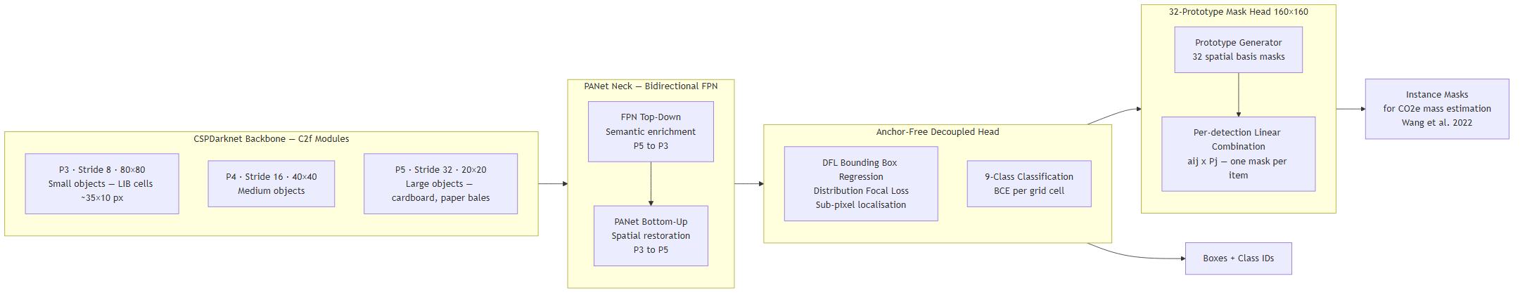
Figure 2: YOLOv8m-seg Three-Component Architecture

3.4.2 Training Configuration
Training runs on a Linux system with CUDA-accelerated GPU via the Ultralytics YOLO Python API. All hyperparameter selections are justified against the specific statistical properties of dataset_master and the deployment requirements of PurityLoop AI.
Table 3.4.1 — Training Configuration
Hyperparameter | Value | Technical Justification
Epochs ceiling | 1,000 | Convergence ceiling; early stopping terminates training at plateau
Early stopping patience | 50 | Halts training if val/mAP@0.5 shows no improvement for 50 consecutive epochs — prevents overfit without premature termination
Batch size | 32 | VRAM-constrained practical batch size
Nominal batch size (nbs) | 64 | 2-step gradient accumulation: effective batch of 64 per parameter update
Optimiser | SGD | Superior generalisation vs. Adam on imbalanced datasets — see justification below
Momentum | 0.937 | Gradient smoothing coefficient; standard YOLOv8 configuration (Terven et al., 2023)
Weight decay | 1×10⁻⁴ | L2 regularisation — prevents overfit on food_organic majority class
lr0 → lrf | 1×10⁻² → 1×10⁻⁴ | Cosine annealing with 3-epoch linear warm-up — see justification below
Label smoothing ε | 0.1 | Prevents logit saturation on food_organic majority class — see justification below
Loss function | BCE + CIoU + Focal mask | Standard YOLOv8-seg compound; focal component addresses class imbalance (Ren et al., 2024)
Input resolution | 640×640 | Standard YOLOv8 input scale; P3 at 80×80 provides 8-pixel granularity for small-object detection
Pretrained weights | yolov8m-seg.pt | ImageNet-pretrained backbone; reduces convergence time and data requirement

Optimiser Selection — SGD over Adam. Adam's adaptive learning rate mechanism estimates per-parameter learning rates from first-moment (gradient mean) and second-moment (gradient variance) history. On class-imbalanced datasets, the second-moment accumulator for low-frequency classes (textile: 17,734 images; battery: 12,814 images post-augmentation) accumulates more slowly than for the majority class (food_organic: 139,909 raw images, capped to 5,000 at training time), resulting in attenuated effective learning rates for minority classes precisely when elevated learning rates are needed for adequate gradient signal. SGD with momentum=0.937 applies a uniform learning rate across all parameters with gradient smoothing, delegating class-specific gradient weighting to the focal loss and label smoothing mechanisms, without the interference of adaptive second-moment attenuation. This behaviour is consistent with the training configuration reported for all YOLOv8 variants by Terven et al. (2023), who empirically validate SGD as the superior optimiser for YOLO-family training on detection benchmarks.
Learning Rate Schedule — Cosine Annealing with Warm-Up. The learning rate follows lr(t) = lrf + 0.5(lr0 − lrf)(1 + cos(πt/T_max)) after a 3-epoch linear warm-up from 1×10⁻⁴ to lr0. The warm-up prevents large initial gradient steps on the randomly initialised detection head from destabilising the pretrained backbone representations before the head has adapted sufficiently to waste domain semantics. Cosine annealing then provides a smooth, monotonically decreasing schedule that avoids the discontinuous loss landscape perturbations of step-decay schedules while converging toward a loss minimum with progressively smaller update steps. For a nine-class detection task with complex loss landscape from competing class gradients, the cosine schedule's gradual decay preserves training stability through the later epochs where fine-grained discriminative features for visually similar classes (plastic vs. glass, food organic vs. general trash) are acquired.
Gradient Accumulation (nbs=64). The effective batch size of 64 is achieved by accumulating gradients over two sequential forward passes (batch=32 each) before a single parameter update. An effective batch of 64 images per update provides more representative class distribution coverage per gradient step than batch=32 alone — for a nine-class dataset with the battery class comprising approximately 5.6% of the capped training set, gradient accumulation increases the expected number of battery-class samples contributing to each parameter update from approximately 1.8 (batch=32) to 3.6 (nbs=64), improving the battery class gradient signal per update step without requiring additional GPU VRAM.
Label Smoothing ε=0.1. Hard one-hot target vectors in standard cross-entropy loss create zero training loss on correctly classified examples — once the model assigns high logit to the correct class, no gradient flows for that sample, regardless of whether the logit magnitude is reasonable or extreme. For the food_organic majority class (81,927 raw images, the dominant class in the un-capped dataset), this creates a degenerate training dynamic: the model can achieve near-zero loss by concentrating representational capacity on food_organic discrimination, starving gradient signal from minority classes. Label smoothing converts the one-hot target for class k from 1 to (1 − ε) + ε/K = 0.911 and all non-target class targets from 0 to ε/K = 0.011, maintaining a non-zero training loss even on correctly classified examples and distributing gradient signal across all classes throughout training (Md. Nahiduzzaman et al., 2025).

3.4.4 Two-Phase Training Protocol
The training protocol is structured as two sequential phases with distinct objectives, governed by a safety-critical model selection gate for battery class recall.
Phase 1 — Head Adaptation with Backbone Frozen (Epochs 1–50). The CSPDarknet backbone layers are frozen (requires_grad=False) during Phase 1; only the PANet neck, detection head, and mask segmentation head parameters receive gradient updates. Learning rate warm-up proceeds linearly from 1×10⁻⁴ to lr0=1×10⁻² over the first three epochs, then remains at lr0 for the remainder of Phase 1.
The rationale for backbone freezing addresses catastrophic forgetting in transfer learning: when a network pretrained on ImageNet (1.28M images, 1,000 object categories) is fine-tuned on a domain-shifted task without frozen layers, backpropagated gradients from the new task's loss overwrite generalised feature representations in the backbone with task-specific activations. The backbone's early layers — which encode domain-agnostic visual features (Sobel-like edge detectors, colour gradient maps, Gabor-like texture filters) learned from 1.28M images — are irreplaceable by the 36,000 training images in the capped dataset_master partition. Phase 1 protects these representations by restricting gradient flow to the detection and segmentation head, which adapts from ImageNet-trained semantics (1,000-class natural object categories) to the nine-class waste taxonomy. This phase completes the semantic adaptation of the head without disrupting backbone feature representations that will be essential for cross-class discrimination in Phase 2.
Phase 2 — Full Fine-Tuning (Epochs 51–1,000, patience=50). All layers are unfrozen (requires_grad=True); cosine LR decays from lr0=1×10⁻² to lrf=1×10⁻⁴. Early stopping monitors val/mAP@0.5 over 50 consecutive epochs; training terminates on a sustained plateau.
The rationale for full fine-tuning in Phase 2 addresses the domain transfer gap between ImageNet and waste imagery. While early-layer backbone features (edge, colour gradient, texture) transfer across visual domains without adaptation, mid-level and deep-level backbone features encode semantic representations tuned to natural image categories — fine-grained plumage patterns, vehicle component sub-structures, human pose configurations — that are semantically misaligned with waste item representations. Full fine-tuning in Phase 2 allows the backbone to develop domain-adapted waste-semantic representations using the stable waste taxonomy already established by the Phase 1 head adaptation as a training anchor, avoiding the representation collapse that occurs when an unadapted head and backbone are trained simultaneously from the first epoch.
Battery Class Recall Gate. After epoch 100, at each validation epoch, only model checkpoints satisfying battery class recall ≥ 0.90 are logged as gate-passing checkpoints eligible for final model selection. Checkpoints where battery class recall falls below 0.90 — regardless of aggregate mAP@0.5 performance — are explicitly excluded from model selection. Final model selection uses the highest val/mAP@0.5 among all gate-passing checkpoints.
The asymmetric gate criterion reflects the asymmetric cost structure of classification errors in MRF deployment. A false negative on any recyclable class (plastic, paper, cardboard, metal, glass, textile, food organic, general trash) costs material recovery value — economically quantifiable, operationally recoverable through reprocessing or downstream quality control. A false negative on battery class (class 7) allows an undetected LIB to proceed to the mechanical crushing stage, where Terazono et al. (2024) document that physical impact on a LIB casing initiates thermal runaway in 80–90% of incidents. The expected cost differential between a recyclable false negative and a battery false negative is multiple orders of magnitude — the battery false negative triggers a fire hazard with facility-level operational impact. This cost asymmetry justifies the operational constraint that aggregate accuracy optimisation is formally subordinate to battery recall, implemented through the gate mechanism rather than through loss weighting alone (which cannot guarantee per-class recall floors without the gate enforcement).
Figure 3: Two-Phase Training Protocol with Battery Recall Gate
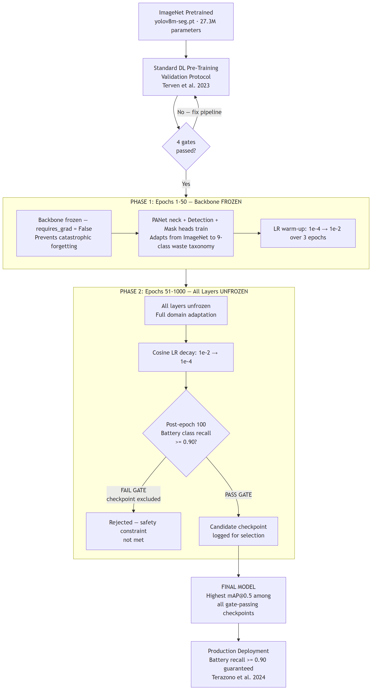
Figure 3: Two-Phase Training Protocol with Battery Recall Gate

References
References
Arishi, A. (2025). Real-Time Household Waste Detection and Classification for Sustainable Recycling: A Deep Learning Approach. Sustainability, 17(5), 1902–1902. https://doi.org/10.3390/su17051902
Atsushi Terazono, Masahiro Oguchi, Akiyama, H., Hiromitsu Tomozawa, Hagiwara, T., & Nakayama, J. (2024). Ignition and fire-related incidents caused by lithium-ion batteries in waste treatment facilities in Japan and countermeasures. Resources Conservation and Recycling, 202, 107398–107398. https://doi.org/10.1016/j.resconrec.2023.107398
Faizul Rakib Sayem, Bin, S., Mansura Naznine, Nashbat, M., Mazhar Hasan-Zia, Ansaruddin, A. K., Amith Khandakar, Ashraf, A., Majid, M. E., Saad, & Muhammad. (2024). Enhancing waste sorting and recycling efficiency: robust deep learning-based approach for classification and detection. Neural Computing and Applications. https://doi.org/10.1007/s00521-024-10855-2
Md. Nahiduzzaman, Ahamed, M. F., Mansura Naznine, Karim, M. J., Kibria, H. B., Ayari, M. A., Amith Khandakar, Ashraf, A., Ahsan, M., & Haider, J. (2025). An Automated Waste Classification System Using Deep Learning Techniques: Toward Efficient Waste Recycling and Environmental Sustainability. Knowledge-Based Systems, 113028–113028. https://doi.org/10.1016/j.knosys.2025.113028
Mustafa, F., Smolarski, J., & Ahmed A. Elamer. (2025). The Convergence of Artificial Intelligence and Sustainability Reporting: A Systematic Review of Applications, Challenges and Future Directions. Business Strategy and the Environment. https://doi.org/10.1002/bse.70090
Pongboonchai-Empl, T., Antony, J., Garza-Reyes, J. A., Komkowski, T., & Tortorella, G. L. (2023). Integration of Industry 4.0 technologies into Lean Six Sigma DMAIC: a systematic review. Production Planning & Control, 35(12), 1–26. https://doi.org/10.1080/09537287.2023.2188496
Ren, Y., Li, Y., & Gao, X. (2024). An MRS-YOLO Model for High-Precision Waste Detection and Classification. Sensors, 24(13), 4339–4339. https://doi.org/10.3390/s24134339
Terven, J., Córdova-Esparza, D.-M., & Romero-González, J.-A. (2023). A Comprehensive Review of YOLO Architectures in Computer Vision: From YOLOv1 to YOLOv8 and YOLO-NAS. Machine Learning and Knowledge Extraction, 5(4), 1680–1716. https://doi.org/10.3390/make5040083
Venturi, S., Zulauf, K., Cuel, R., & Wagner, R. (2024). Trash to treasure: Gamification and informed recycling behavior. Resources Conservation and Recycling, 215, 108108–108108. https://doi.org/10.1016/j.resconrec.2024.108108
Wang, T., Li, K., Liu, D., Yang, Y., & Wu, D. (2022). Estimating the Carbon Emission of Construction Waste Recycling Using Grey Model and Life Cycle Assessment: A Case Study of Shanghai. International Journal of Environmental Research and Public Health, 19(14), 8507. https://doi.org/10.3390/ijerph19148507

